

**East West University**

**Department of CSE**

**LAB REPORT**

|  |  |  |
| --- | --- | --- |
| **Course Code and Name:**  CSE251  Electronic Circuits | | |
| **Experiment no:02** | | |
| **Experiment name:**  **Half-Wave Diode Rectifier Circuit** | | |
| **Semester and Year:**  **Spring 2023** | **GROUP NO: 08** | |
| **Name of Students & Student IDs:** | **Course Instructor information:**  M Saddam Hossain Khan  Senior Lecturer,  Department of  Computer Science and Engineering  East West University | |
| **Date of Report Submitted:22-3-2023** | **Pre-Lab Marks:** |  |
| **Post Lab Marks:** |  |
| **TOTAL Marks:** |  |

**ABSTRACT**

The purpose of this experiment is to better understand the half-wave diode rectifier circuit and its properties. This experiment gives us a thorough understanding of how to use a half-wave rectifier to convert an AC voltage source into a reliable DC voltage source. A capacitor can be connected in parallel with the load to stabilize the output DC voltage and lower the peak-to-peak ripple voltage after the AC voltage has been rectified to a DC voltage by a diode. These ideas allow us to convert an AC voltage source into a steady DC output.

**OBJECTIVES**  
1. We will be able to study half-wave diode rectifier circuit.  
2. It will help us to study the effect of a capacitor filter on the output of the rectifier  
circuit.

**Circuit Diagram:**

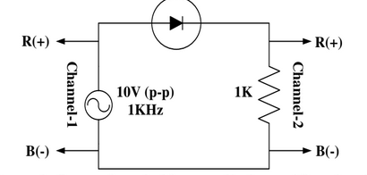

**Figure: A half-wave diode rectifier circuit.**

**Theory And Experimental Methods:**

A rectifier circuit converts an AC voltage with zero average into a unidirectional  
voltage with a non-zero average. The rectifier circuit can rectify both positive and  
negative half-cycles (full-wave rectifier) or only the positive half-cycle (half-wave  
rectifier) of a sine wave. A capacitor connected across the load resistor acts as a filter  
and reduces the ripple of the output voltage. The time constant of the RC network  
should be much larger than the period of the AC source voltage for effective filtering.

**Procedures:**

1. All the circuit elements are measured and was written down.

2. The given circuit is constructed using all the given circuit elements.

Figure 2: Set up for the half wave diode-rectifier circuit

3. A sine wave of 10V peak-to-peak, 1KHz frequency was taken from the signal

generator and was observed in channel-1 of the oscilloscope.

4. The input is given to the circuit and the output is observed in channel-2 of the

oscilloscope.

5. Both the input and output voltage are observed in the oscilloscope in channel-1 and

channel-2 by setting dual mode.

6. The difference in peak input and output values are measured and written down.

7. The given capacitor is connected to circuit in parallel with the load resistance.

8. The diode conduction time (time between the lower peak to the upper peak of the

ripple voltage = time of charging the capacitor) is measured and written down.

9. The peak to peak ripple voltage from the oscilloscope is taken and written down.

10. Average value of the output voltage V0 is measured using the DC mode of the multi-

meter and written down.

1. All the circuit elements are measured and was written down.

2. The given circuit is constructed using all the given circuit elements.

3. A sine wave of 10V peak-to-peak, 1 KHz frequency was taken from the signal generator and was observed in channel-1 of the oscilloscope.

4. The input is given to the circuit and the output is observed in channel-2 of the oscilloscope.

5. Both the input and output voltage are observed in the oscilloscope in channel-1 and channel-2 by setting dual mode.

6. The difference in peak input and output values are measured and written down.

7. The given capacitor is connected to circuit in parallel with the load resistance.

8. The diode conduction time (time between the lower peak to the upper peak of the ripple voltage = time of charging the capacitor) is measured and written down.

9. The peak to peak ripple voltage from the oscilloscope is taken and written down.

10. Average value of the output voltage V0 is measured using the DC mode of the multi-meter and written down.

**Experimental Datasheet:**

|  |  |  |
| --- | --- | --- |
| Measured value of resistance ,R= 0.98 kΩ | ∆VP= 0.6V | ∆t = 110µs |
| Average value of output voltage  VO= 3.11 V | Peak to peak ripple voltage  Vr = 680 mV = 0.68 V | |

**Results And Discussion:**

**From the experiment we get,**

1. Measured value of peak to peak voltage, ∆ V P = 0.4 V

Built-in Voltage = 5 V

Difference = (5-4.4) V = 0.6 V

So we have a different peak to peak value of voltage which is not desirable.

1. Measured conduction time, Δt = 110 µs

Calculated pre-lab conduction time, Δt = 71.78 µs

So, we can see that there was a large difference between the measured and calculated value of Δt in our experiment.

The difference between the measured value and calculated value, = (110-71.78) µs = 38.22 µs

Our calculated and measured conduction time has a difference of 38.22 µS

1. We know, ωΔt = $\frac{√2Vr}{Vp}$

Thus, Peak to peak ripple voltage, ωΔt= 0.928 V

Now, Pre-Lab value = 0.5 V

Measured Value = 0.68 V

Difference between calculated value and measured value = (0.928 – 0.68) = 0.248 V

Difference between pre-lab value and measured value = (0.68 – 0.5) = 0.18 V

So all of our values of peak to peak ripple voltage differs slightly, so either our measurement was incorrect or the experiment did not go properly.

1. Average output voltage, V0avg = Vp - Vr/2 = 4V

Measured average output voltage V0avg  = 3.11V

Difference: 4 - 3.11 = 0.89V

There is a difference between the measured and calculated values which should not normally happen.

1. IL= = 3.17 mA

IDAvg = IL(1+π√Vp/Vr) = 28.50 mA

IDMax = IL(1+2π√Vp/Vr) = 53.84 mA

Measured value of Vr = 0.68 V

Now, Pre-lab values :

IDAvg = 71.49 mA

IDmax =138.22mA

Vr= 0.5V

Thus, difference of IDAvg = 42.99mA

Difference of IDMax = 84.38mA

Difference of Vr = 0.18 V

**6.**

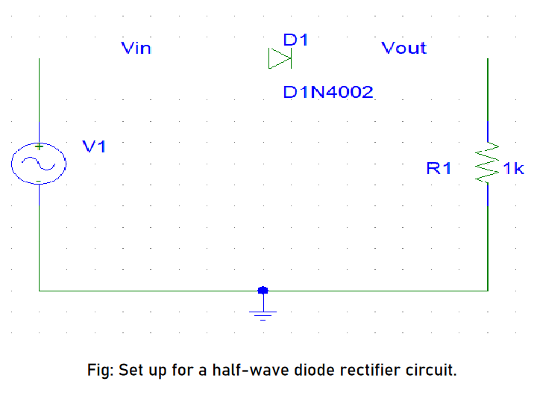

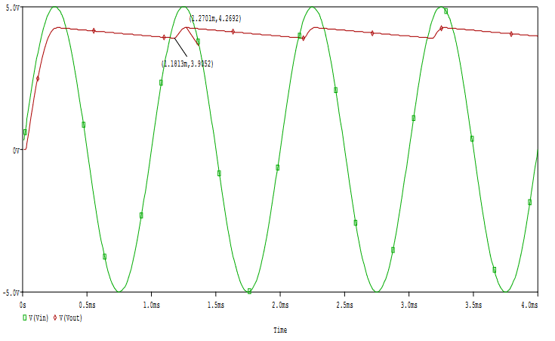

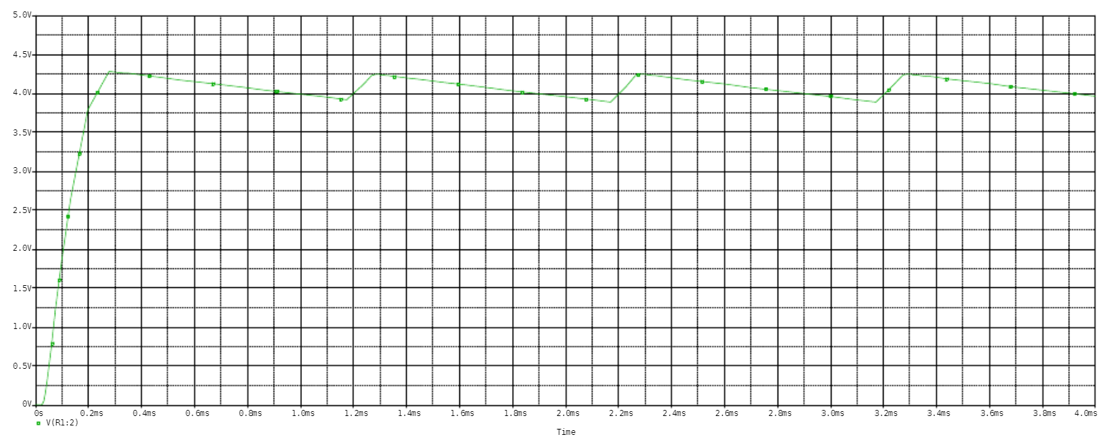

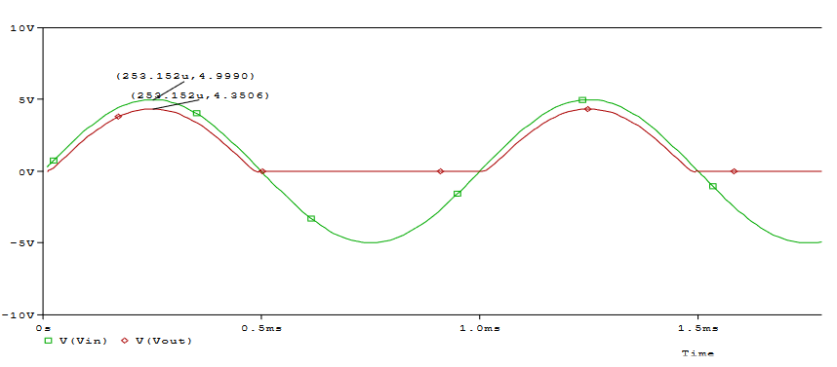

**Figure: Simulated rectified sine wave with capacitor**

**Conclusion:**

A half-wave rectifier only conducts for half of an AC sinusoid voltage, and diodes function as a one-way rectifier, according to the results of this experiment. It may be transformed into a constant Dc voltage supply by using a capacitor. In this experiment, we used the oscilloscope to simulate a sinusoid and measure peak-to-peak voltage as well as ripple voltage. We learned the characteristics of the rectified voltage as well as what happens when a capacitor is included in the circuit.

**Pre-Lab question’s Answers**:

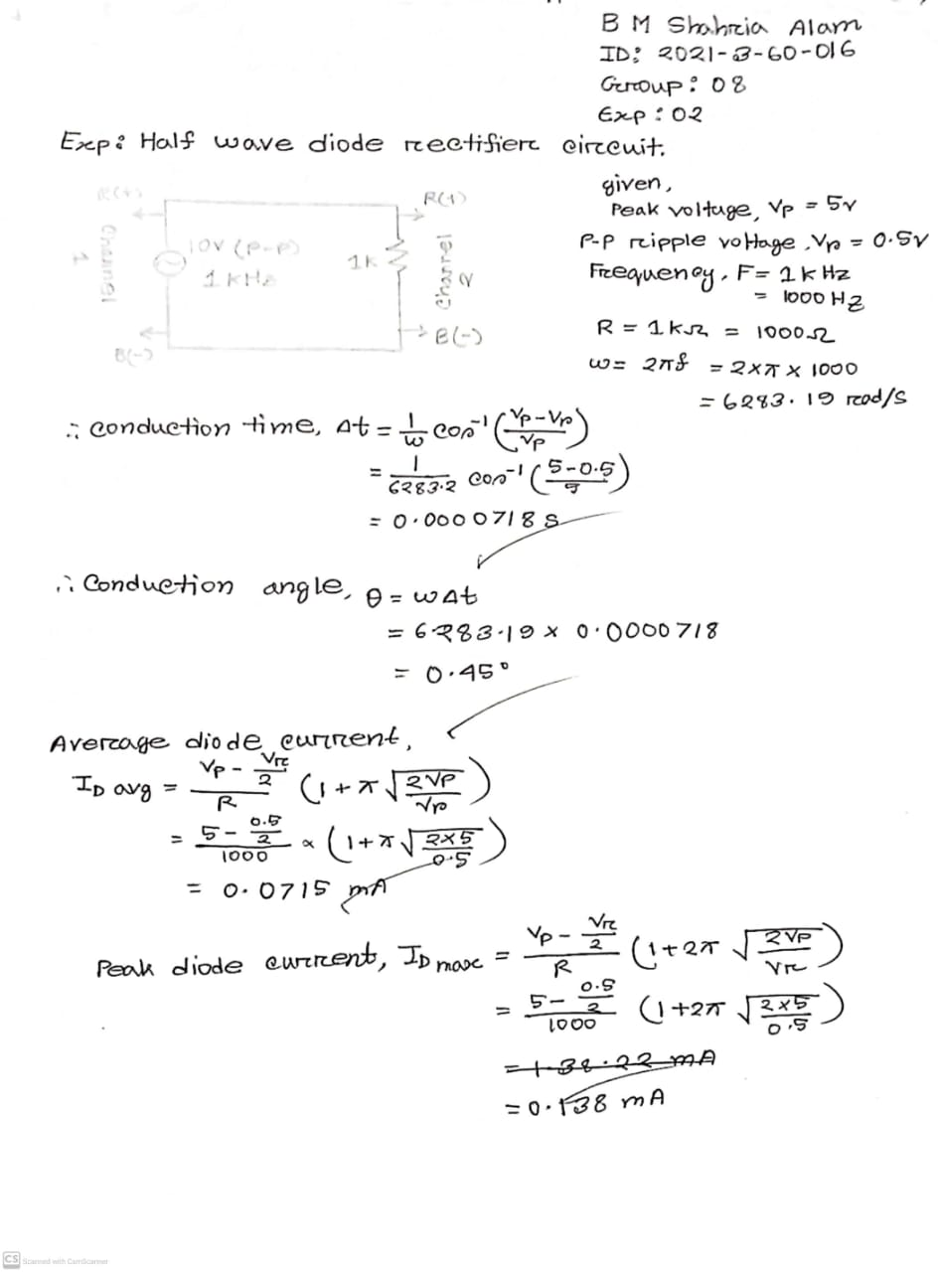

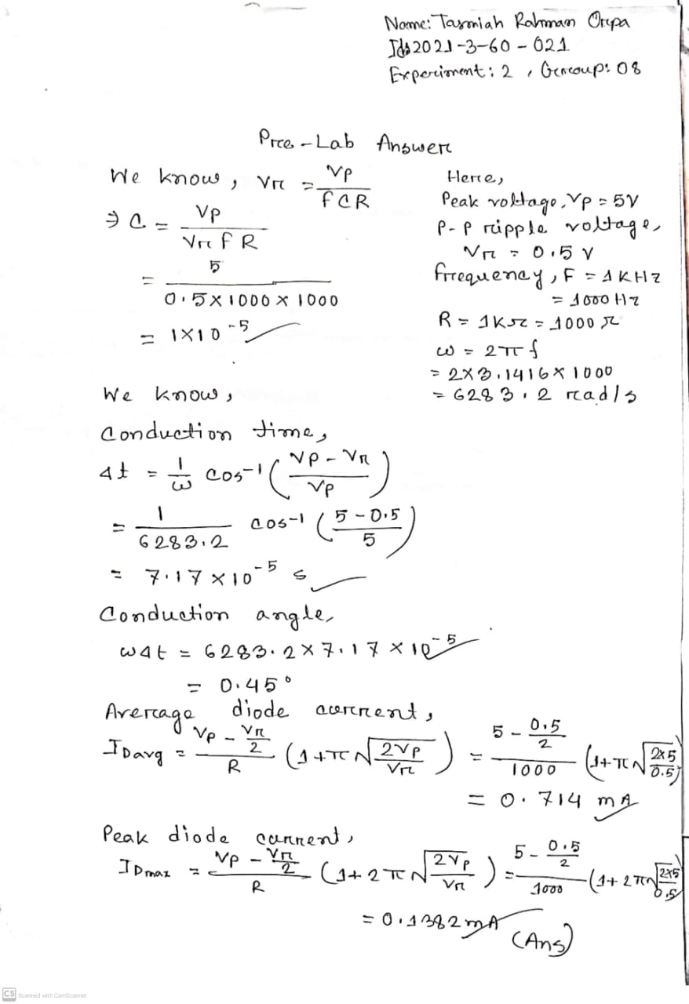

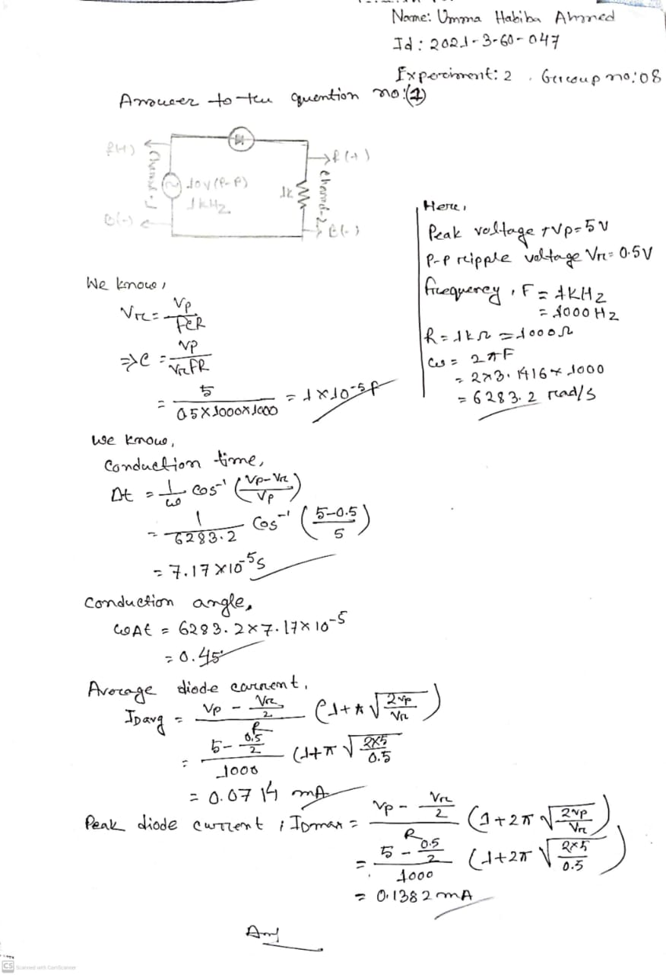

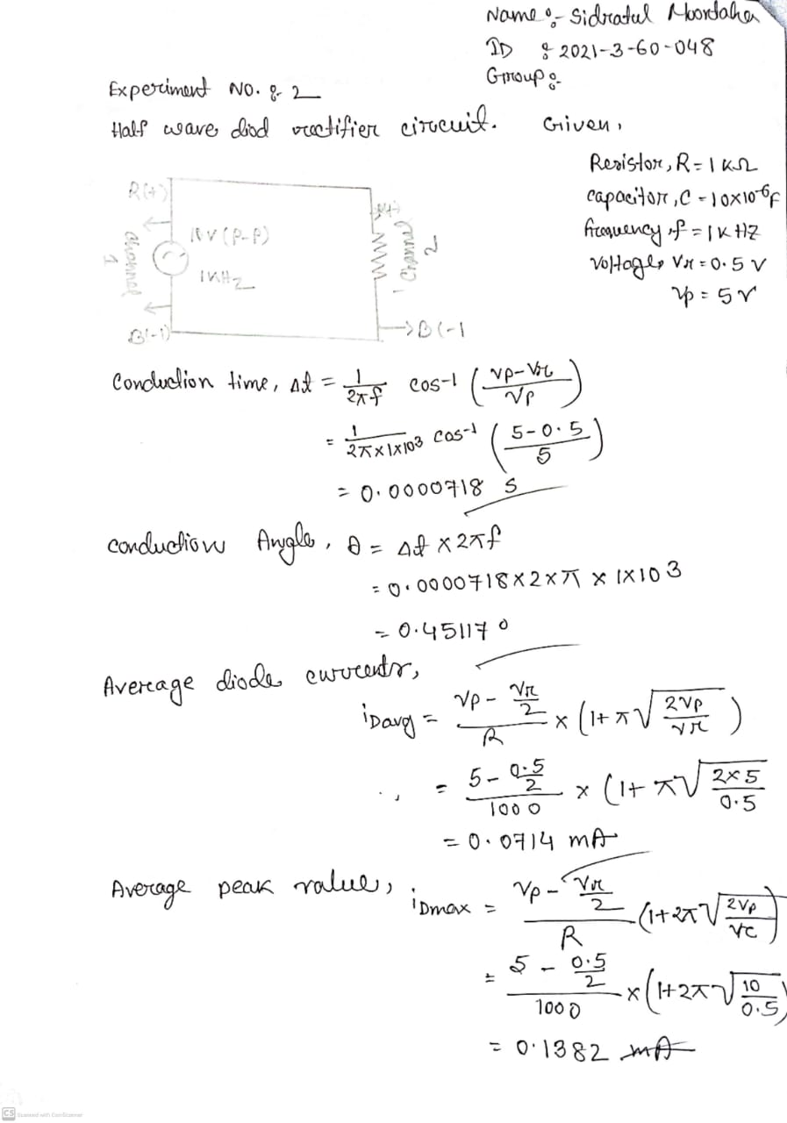[1]

1.